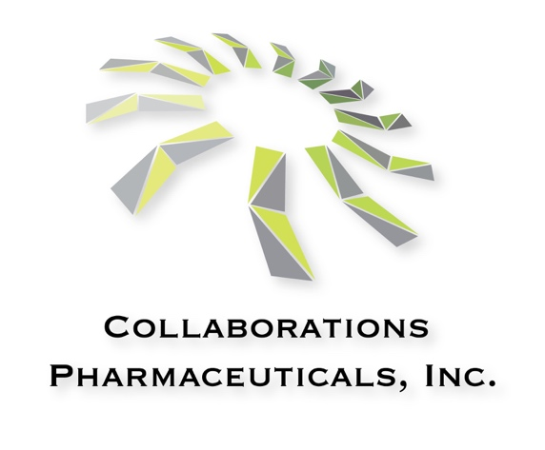
Collaborations Pharmaceuticals, Inc. Summer Projects 2024
Collaborations Pharmaceuticals Inc is a local biotech developing clinical candidates for rare and neglected diseases. We currently have NIH and DOD funded projects ongoing for projects on applying software for various drug discovery and toxicology applications. Our approach uses machine learning using our software products to identify or design new molecules. Students will experience how a small (approx. 12 scientists) dynamic company can work on an array of projects that can impact human health. http://www.collaborationspharma.com/
Projects available include:

- Chemist - Generative design project for psychoplastogens
We would like a chemist /cheminformatics student who can help apply our MegaSyn software and design/make the molecules and test them. The student would obtain valuable experience of working in a pretty topical area for the industry right now.

- Chemist - Tuberculosis antibody drug conjugate
We aim to develop an antibody drug conjugate for tuberculosis. To date we have synthesized the drug+linker and have identified and characterized a suitable antibody. We now need to conjugate the drug+linker and antibody and perform analytical work to ensure the product is made prior to in vitro testing. An ideal project for a chemistry student who wants to find a therapeutic application.

- Biologist- Neurodegenerative disease
We have an enzyme replacement therapy for Batten disease and would like to see if it could be useful for other neurodegenerative diseases. We would be keen to find a cellular neurobiologist to test in neuronal cells. This would be a lab- based project to use cell culture etc.

- Chemist/ biologist - Machine learning and drug transporters
We have developed and published on numerous models for human drug transporters (uptake and efflux). We have some flexibility in selecting these proteins, obtaining data to model then generating models to enable prospective predictions. We have funding to buy compounds and send to collaborators and CROs to perform testing.

- Chemist/ biologist - Machine learning and toxicity / anticancer targets
We have recently developed suites of machine learning models for the Estrogen Receptor, Androgen Receptor. Besides representing important targets for endocrine disruption, they are also targets for cancer. We would like to use these models using our Assay Central software to virtually screen millions of commercial compounds, select those that score well and test internally. Our goal is to find compounds as starting points for anti-cancer projects. This would be an ideal project for a biologist / cancer researcher with an interest in machine learning. They would gain experience of how we could generate pathway models for different diseases and find molecules that could be potential therapeutics.

- Software development - Cheminformatics
If you have an interest in software development we are looking for creative scientists that could develop new tools for drug discovery. We have several software projects and there would be flexibility in selection. Recent examples of tools developed by us include UV-AdVISor, MegaAChE, large language models for toxicity prediction, Quantum machine learning etc.

Contact
Sean Ekins, Ph.D., D.Sc.
CEO and Founder,
Collaborations Pharmaceuticals, Inc.
840 Main Campus Drive, Lab 3510
Raleigh, NC 27606

sean@collaborationspharma.com
cell:215-687-1320
office: 919-515-5941

